Pre-existing Fracture in a Helicopter Composite Rotor Blade System

Torstens Skujins, Ph.D., P.E.
Senior Engineer, Exponent
Dr. Torstens Skujins is a Senior Engineer in the Mechanical Engineering Practice at Exponent. He holds Ph.D. and Master’s degrees in aerospace engineering from the University of Michigan and a B.S.E. degree in mechanical engineering from Duke University. At Exponent, Dr. Skujins has worked on a variety of problems and failure analyses, including issues involving helicopter blades, wind turbines, satellites, and other items. tskujins@exponent.com
Joseph F. Rakow, Ph.D., P.E.
Principal Engineer and Practice Director, Exponent
Dr. Joseph Rakow advises clients on complex engineering problems from design, manufacturing, and qualification, to field use and field failures. He leads diverse multi-disciplinary investigations to deliver scientific answers to clients’ technical issues. Dr. Rakow is a leading expert in composite materials and structures, and has applied his expertise to composite problems across a broad range of industries. He leads the mechanical engineering practice of Exponent, a large engineering and scientific consulting firm. Dr. Rakow holds Ph.D. and an M.S. degrees in aerospace engineering from the University of Michigan and a B.S. in physics from the University of California, Davis. jrakow@exponent.com

Abstract
On June 16, 2010, a Kaman K-1200 helicopter conducting logging operations in Idaho crashed after its intermeshing rotor blades impacted each other and then separated from the aircraft. Exponent’s examination of the evidence revealed that the root cause of the accident was a pre-existing crack in one of the servo flap control surfaces attached to the outboard sections of the blades. Dried paint was found on the servo flap’s fracture surface, showing that the crack must have been present during the last time the flap was painted and inspected. Failure of the servo flap initiated a chain of events that resulted in the loss of the helicopter and its pilot.

Introduction
On June 16, 2010, a Kaman K-1200 helicopter with registration number N134WC was performing logging operations near Donnelly, Idaho [1]. As the helicopter was pulling a large log off the ground, witnesses reported hearing a loud, unusual noise coming from the helicopter, at which point portions of the rotor blades departed the helicopter and the aircraft subsequently crashed, killing the pilot.
The flight was operating under visual flight rules and an overcast ceiling of 12,000 feet; winds were light and variable, and the temperature was 6° C. The helicopter reportedly was operating at approximately 200 feet off the ground when the accident sequence began, and the accident site is at an elevation of approximately 6,300 feet. The total external weight being lifted by the helicopter was 6,491 pounds, and the total gross weight of the helicopter and the load was 12,288 pounds [1].
The National Transportation Safety Board (NTSB) initiated an investigation into the accident and determined that the accident was caused by “the collision of two counter-rotating main rotor blades for undetermined reasons, which resulted in a loss of control” [2]. Exponent was retained by the owner/operator of the helicopter to identify the root cause of the accident.

Kaman K-1200 Helicopter
Figure 1 shows a photograph of a K-1200 helicopter in flight. The aircraft has two counter-rotating rotors that are located on pylons above the cockpit. Each rotor has two blades. The blades intermesh and are linked by gearing to coordinate their rotation. The normal operating speed for the blades is 270 RPM [3].
During flight, control of the helicopter is achieved through servo flaps mounted on the trailing edge of each blade, as shown in Figure 2. The pilot gives a control input, which causes the servo flaps to deflect. Deflection of the servo flaps causes the blades to twist, thereby changing the lift on the blades and hence controlling the movement of the helicopter.
Figure 3 shows a schematic of the servo flap mechanism. To increase the lift on the rotor blade, as would be required to lift a log off the ground, the pilot provides a control input that raises the trailing edge of the servo flaps. This creates a downward aerodynamic force on the flap, which in turn causes the rotor blade to twist with its leading edge up. Pitching up of the rotor blade leading edge increases the lift, causing the helicopter and its payload to move upward.
The servo flap has a constant cross section along its span, resulting in a rectangular planform with a span of 34.4 inches and an approximate width of 8 inches from the leading edge to the trailing edge. A cross-sectional view of the flap is shown in Figure 4. The flap is attached to the rotor blade with two brackets, visible in Figure 2: one at the inboard edge and the other on the outboard edge of the flap. The material used for the flap is a graphite/epoxy fabric composite.
On N134WC, servo flap 109A was attached to blade 169A. Rotor blades 169A and 169B were attached to the left rotor hub; blades 94A and 94B were attached to the right rotor hub. Figure 5 shows a diagram identifying the serial numbers of these parts of the rotor system.

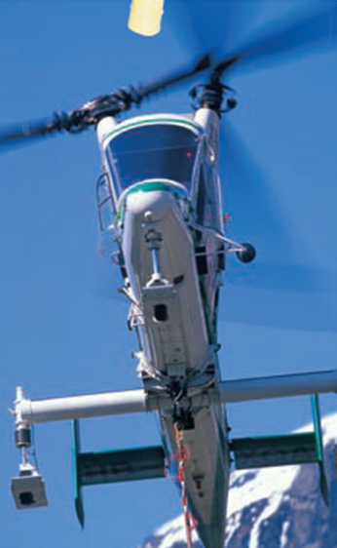

Figure 1. Kaman K-1200; image taken from Kaman K-MAX brochure.
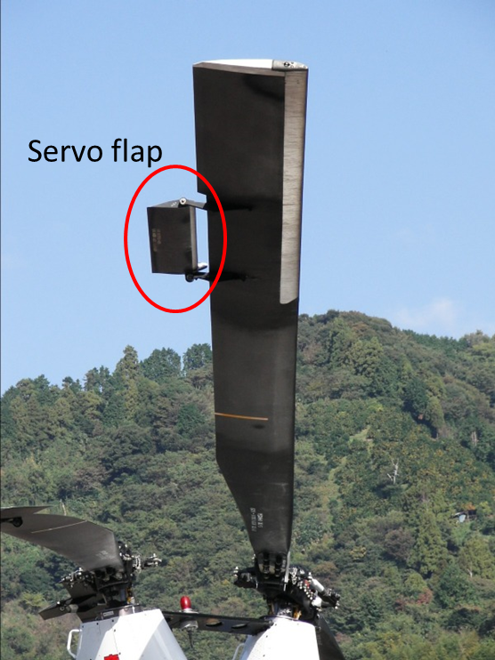
Figure 2. K-1200 servo flap.
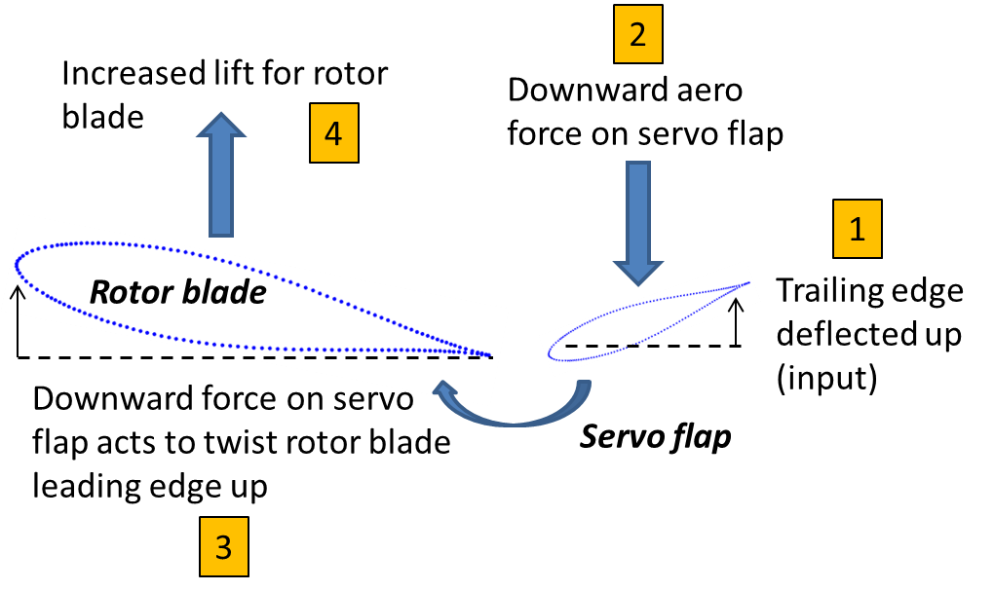
Figure 3. Schematic of servo flap function (not to scale).

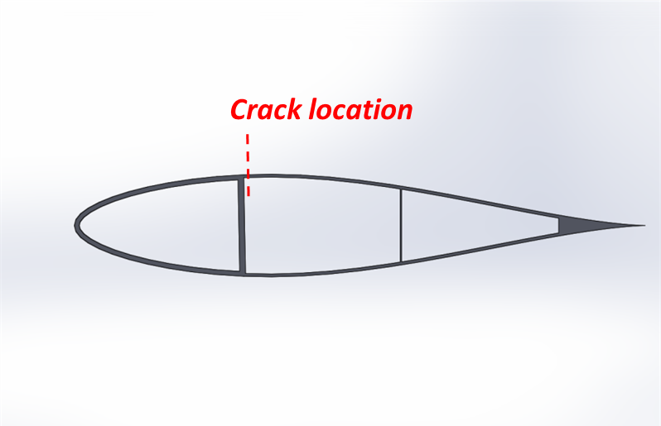
Figure 4. Cross-sectional view of servo flap airfoil shape and internal structure; crack location on top skin indicated.
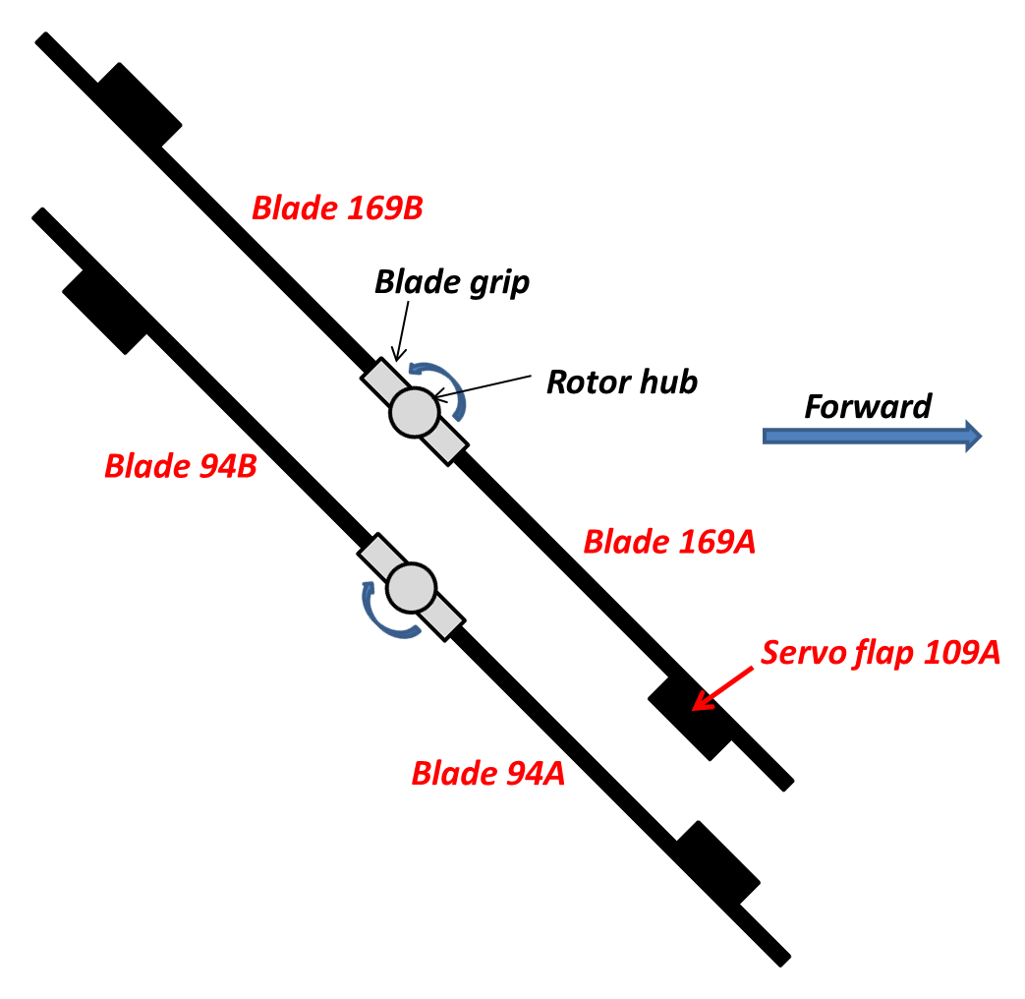
Figure 5. Blade and servo flap locations on N134WC (not to scale).

Servo Flap Fracture Origination and Growth
Servo flap 109A was found in two pieces at the accident site. The leading edge was still attached to blade 169A, which had separated from the rest of the helicopter. The trailing edge, or afterbody, of the flap had completely separated from the leading edge and was lying adjacent to the fuselage and tail [1]. Figure 6 shows an image of the servo flap in its post-accident condition; the forebody was removed from blade 169A during the post-accident investigation.
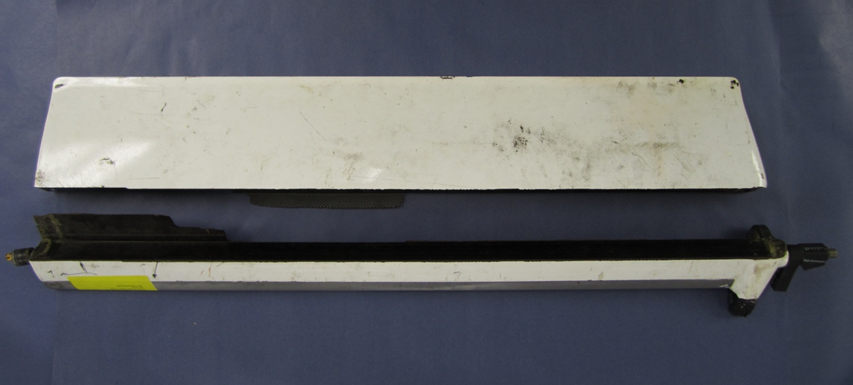
Figure 6. Servo flap in post-accident condition.
Upon receipt, the servo flap was examined both visually and microscopically. The flap did not show evidence of any significant impacts during its final failure. The fracture surfaces indicated that the flap had failed in bending with tension on the top and compression on the bottom. This loading is consistent with the aerodynamic loading associated with the configuration shown in Figure 3.
The next step was a detailed examination of the fracture surface. First, in order to facilitate an up-close look at the surface, material was cut out of the flap, as shown in Figure 7.
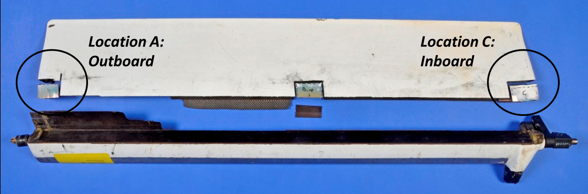
Figure 7. Top view of servo flap 109A showing the detachment of the trailing edge from the leading edge just behind the main spar.

Then the entire fracture surface was examined to identify the direction of crack growth. Figure 8 shows closeup views of the fracture near location C (see Figure 7) on the inboard section of the flap. Zipper marks, visible in the white painted surface along the fracture and extending out from the fracture in a direction toward the trailing edge and outboard section of the flap (traveling from bottom right to top left in the figure), were created in the painted surface as the fracture traveled from right to left, inboard to outboard. This pattern continues at location A on the outboard section of the flap, as shown in Figure 9. In general, these patterns show that the fracture grew from inboard to outboard.
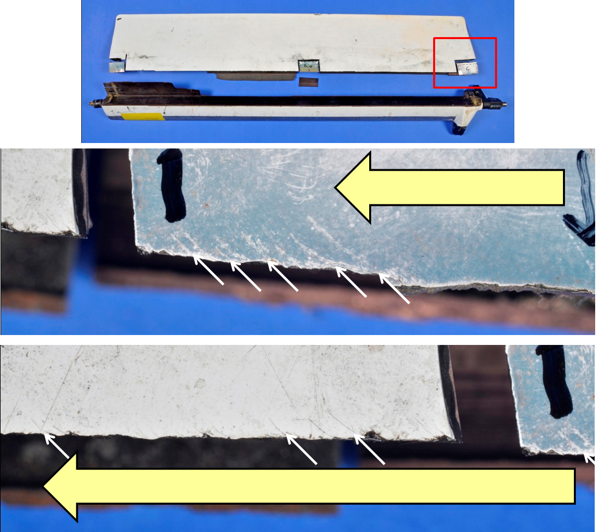
Figure 8. Zipper marks identified by white arrows at location C (inboard). The bold yellow arrow shows the direction of crack propagation.
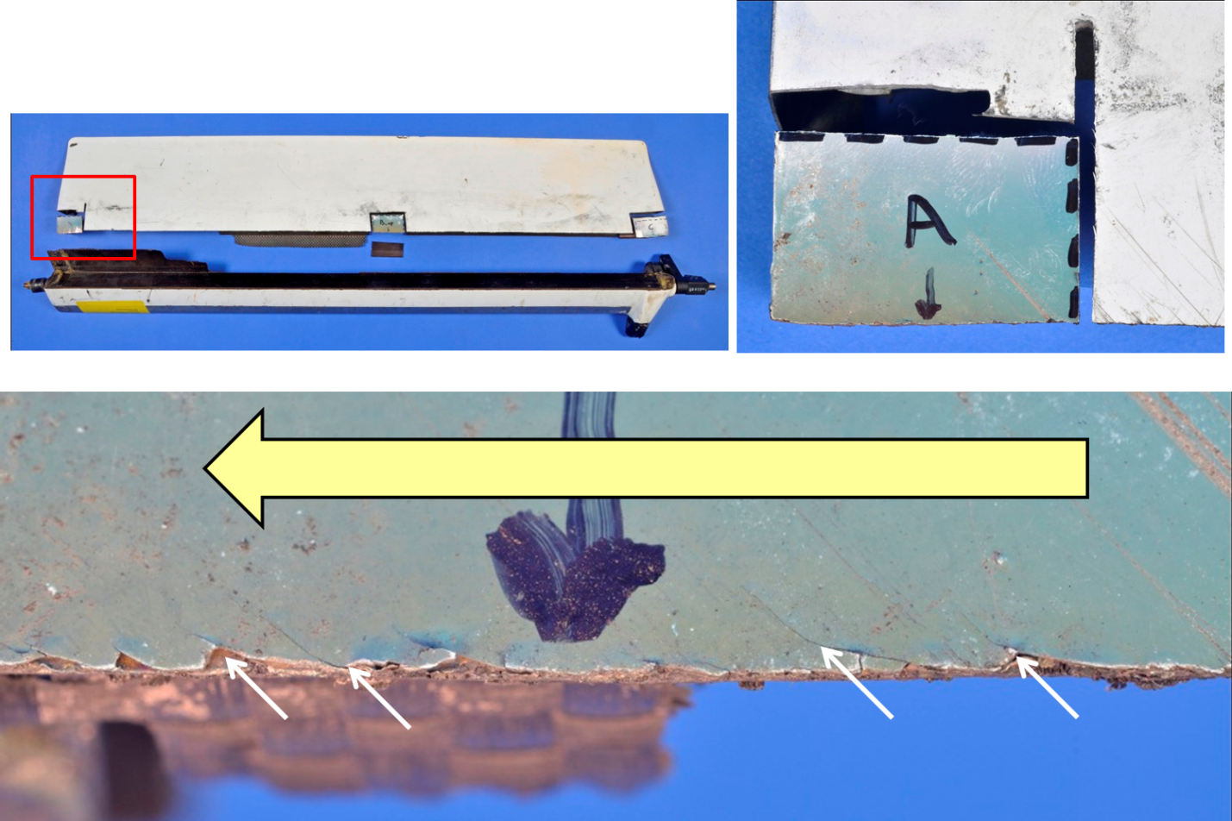
Figure 9. Zipper marks identified by white arrows at location A (outboard). The bold yellow arrow shows the direction of crack propagation.

After determining the direction of crack growth, Exponent examined the area from which the fracture grew (Figure 10). In that area, there is an indentation or impact mark on the top surface of the flap (Figure 11). The indented region appears to have been painted, as crevices within the indentation are filled with paint. Examination of the fracture surface immediately under the indentation revealed paint inside the fracture, present on both mating surfaces of the fracture, as shown in Figure 12. The paint has the same color as the paint on the outside surface of the flap.
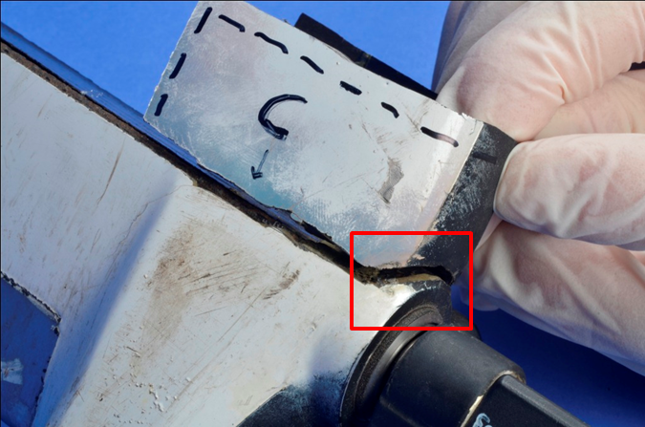
Figure 10. Servo flap area of crack origination; impact damage in red box.
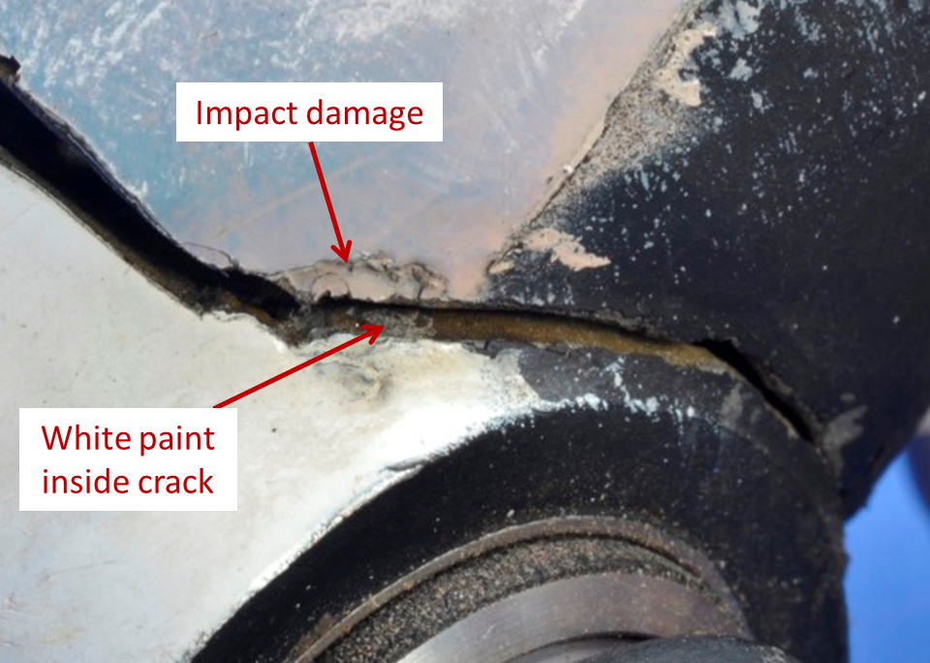
Figure 11. Zoomed-in view of crack origin location showing impact damage as well as white paint inside crack.
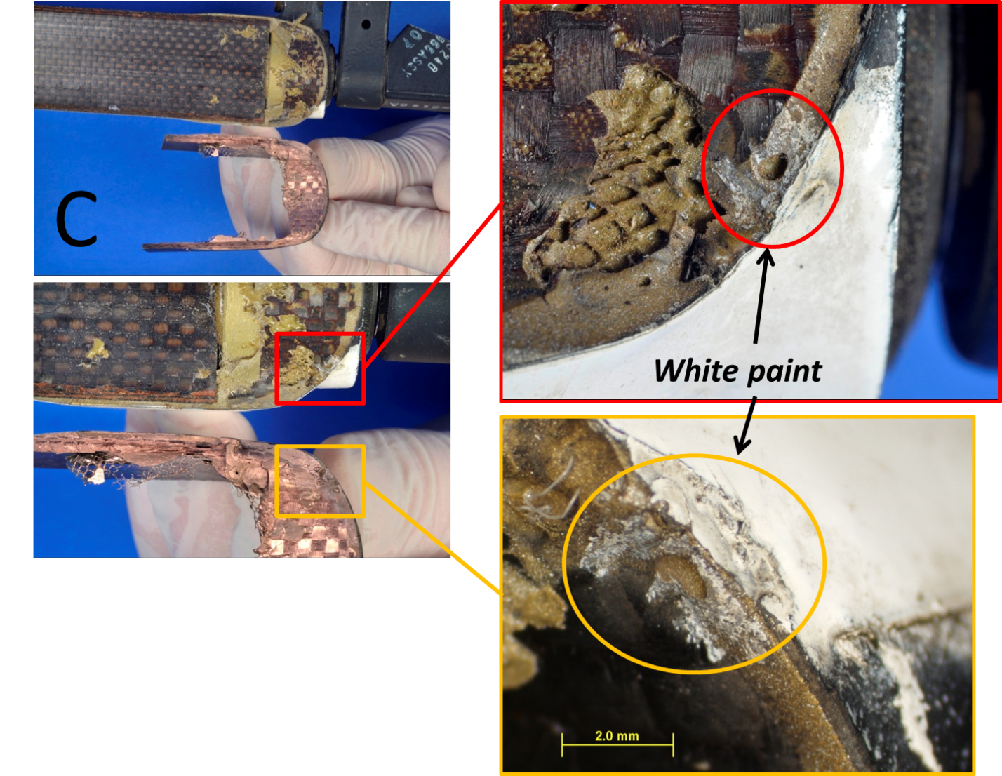
Figure 12. Cross-sectional view of paint in crack at servo flap location C.

To help confirm that the substance on the fracture surface is paint, the fracture surface was analyzed with energy-dispersive spectroscopy (EDS). EDS uses an x-ray beam to identify the elements present at the surface of a sample. Figure 13 shows a microscope image of the white substance on the fracture surface, alongside an EDS map of the surface. The map shows the locations that contain titanium, a common signature element of paint. Note that the shape of the titanium map mimics the shape of the white substance in the microscope image. EDS was performed on the white top surface of the flap, which confirmed the high prevalence of titanium in the paint (Figure 14).
These findings show that some portion of the servo flap fracture was present the last time the flap was painted. The size of the paint mark on the fracture surface indicates only an approximate crack size that was present at the time of painting. During the final flight and lifting of the large log, the loading on the crack reached a threshold that caused the afterbody of the servo flap to break off from the forebody, beginning the accident sequence.

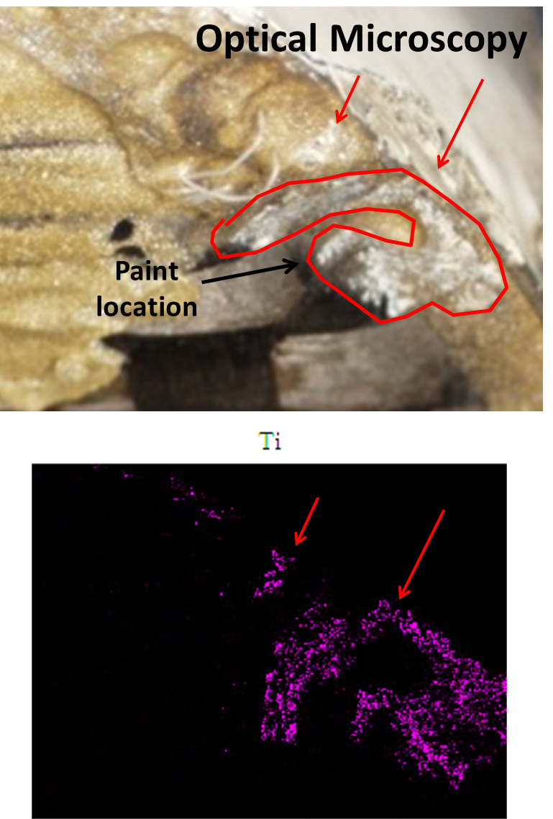
Figure 13. Visual image and EDS map of the crack surface showing the presence of titanium from the paint.
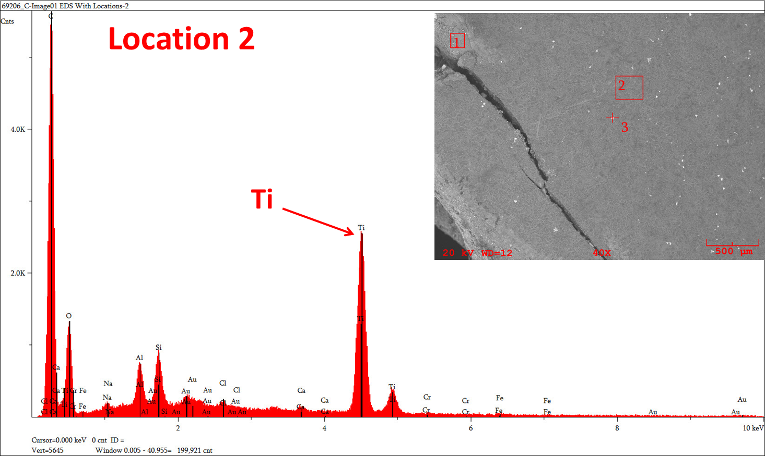
Figure 14. EDS map of the top surface of the servo flap, which is covered in white paint.

Blade Response to Servo Flap Failure
Failure of servo flap 109A initiated a chain of events that led to the downing of the helicopter. At the time of the servo flap failure, the helicopter had just lifted a large log off the ground. The total weight of the helicopter and payload was approximately 12,000 pounds. With four rotor blades on the helicopter, the nominal lift on blade 169A would have been approximately 3,000 pounds.
When servo flap 109A failed, the immediate consequence was the untwisting of the blade and consequently a reduction in lift on the blade. Using a basic strip theory aeroelastic calculation, Exponent estimated the loss of lift to be approximately 1,000 pounds.
This sudden reduction in lift on blade 169A, and sudden imbalance in lift compared to 169B, which still had its servo flap intact, would induce significant oscillations into the helicopter’s rotor system, including significant tilting of the rotor at its teeter pin. These oscillations include vertical deformation of the blades as well as tilting of the blades about the teeter pin at the blade hub. This action produces blade tip deflections of as much as several feet in the vertical direction, sufficient to allow the left and right rotor blades to impact each other.

Rotor Blade Contact
The physical evidence on the rotor blades shows that the blades impacted each other in multiple locations. The blades came into contact with each other at four distinct locations, which are shown in Figure 15. The four contact areas will be discussed below; the numbering of the contact areas does not imply sequence.

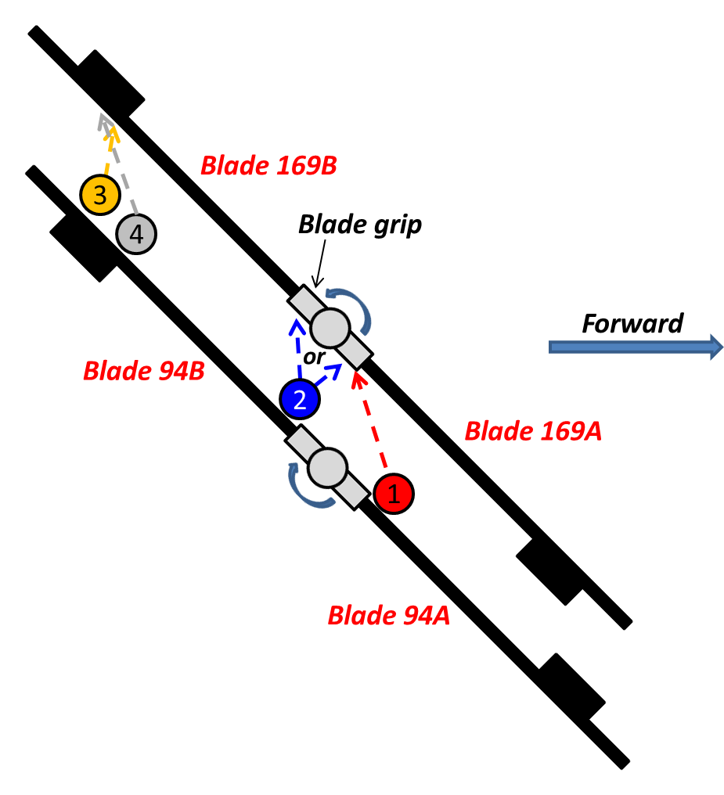
Figure 15. Schematic showing rotor blade contact locations. Drawing not to any scale; number does not imply sequence.
Contact 1 consists of the root of blade 94A and the grip of blade 169A. On blade 94A, the fracture is between stations 50 and 65. Figure 16 shows a photograph of the fracture area on blade 94A. The highlighted scrape marks were generated by impact with the blade 169A grip. As highlighted in Figure 17, a piece of material from the 94A blade was found in the grip after impact. During their investigation, the NTSB matched this material to the 94A blade [3].

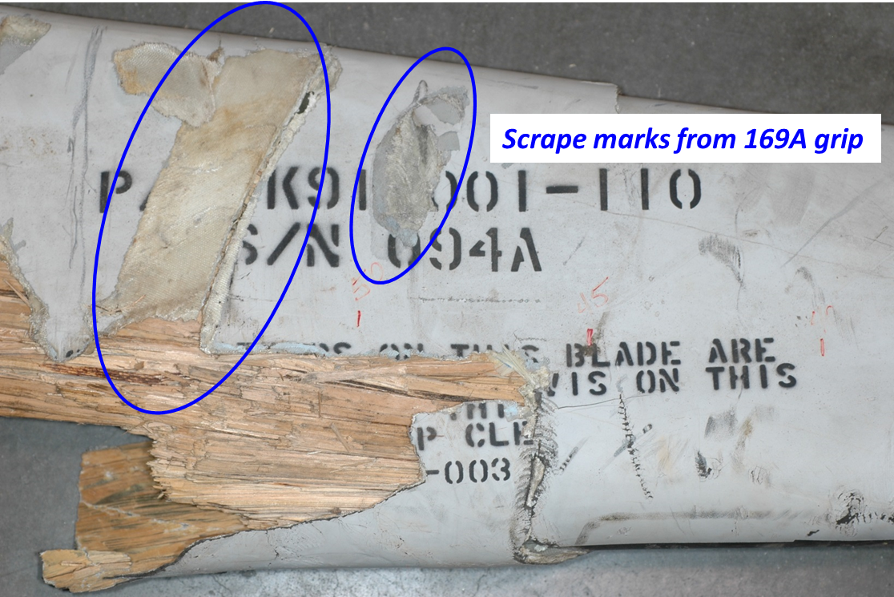
Figure 16. Bottom view of blade 94A showing contact area 1; the highlighted scrapes are from the blade 169A grip.
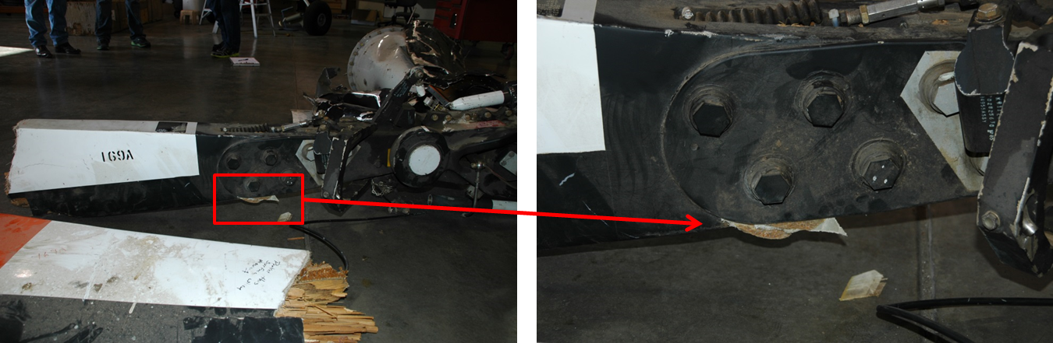
Figure 17. Views of the blade 169A grip (contact area 1) containing material from blade 94A.

Contact area 2 consists of the root of blade 94B [3] and one of the 169A/B grips. Scrape marks are present on the underside of blade 94B (Figure 18) and are similar in nature to the scrapes caused by the grip impact on blade 94A.
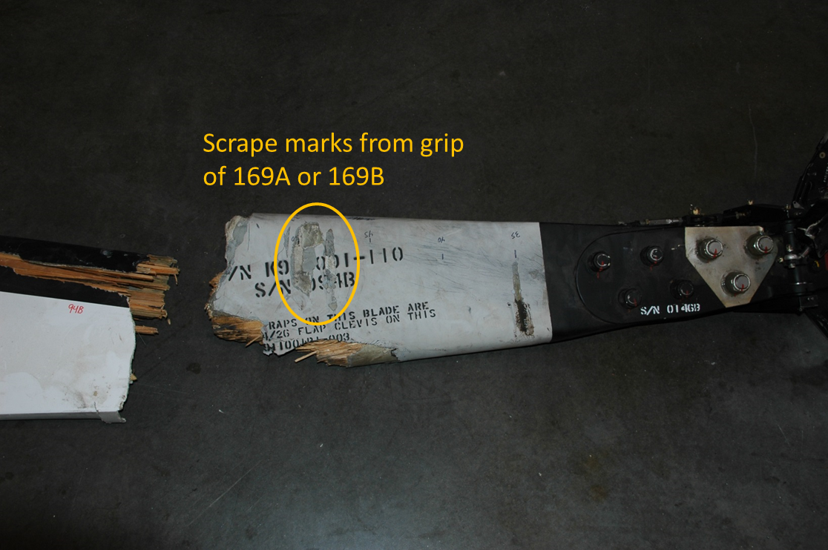
Figure 18. Bottom view of blade 94B showing contact area 2; the scrape marks came from the grip of either 169A or 169B.

Contact area 3 consists of the outboard servo flap bracket on blade 94B (blade station 226) and blade 169B at blade station 198 [3]. The damaged outboard flap bracket, as shown in Figure 19, matches an indentation at station 198 on the leading edge of blade 169B.
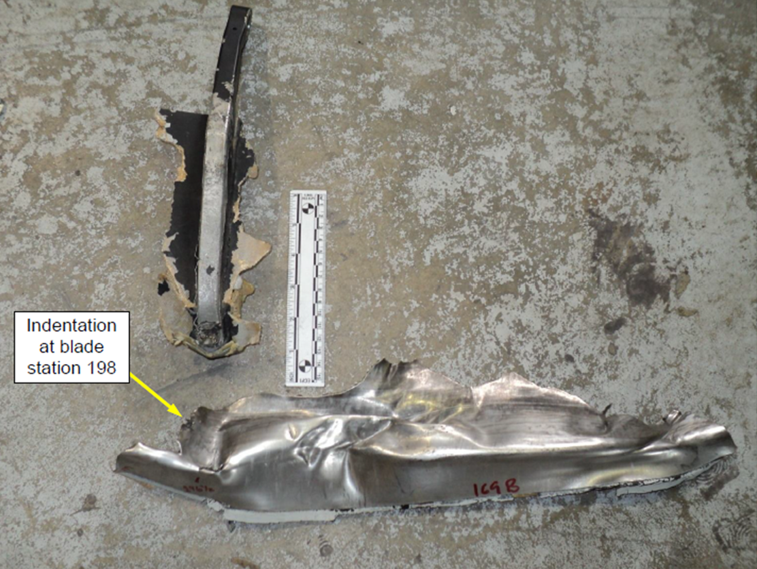
Figure 19. NTSB figure matching outboard bracket from blade 94B with indentation on leading edge of blade 169B [3].
Lastly, as shown in Figure 20, contact area 4 consists of leading edge-to-leading-edge contact between blades 94B and 169B. On blade 94B, this area is centered roughly at station 195, whereas on blade 169B this area is centered roughly at station 205.
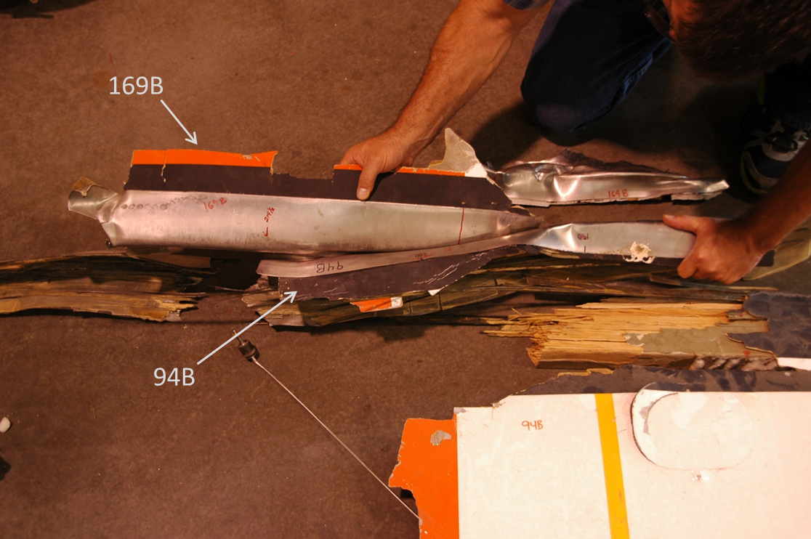
Figure 20. Contact area 4 between the leading edges of 94B and 169B.

Concluding Remarks
The analysis of evidence from the crash of a Kaman K-1200 helicopter revealed that the root cause was a pre-existing crack on one of the servo flap control surfaces. The crack, just aft of the main spar of the servo flap, propagated from inboard to outboard. The fracture at the inboard origin contained an impact mark and dried white paint on the fracture surface, indicating that a portion of the fracture was present the last time the flap was painted.
During flight, servo flap 109A separated from blade 169A, initiating the accident sequence. Large oscillations of the affected blade resulting from dynamic response and aerodynamic imbalance caused the intermeshing rotor blades to impact each other and separate from the rest of the aircraft, after which the helicopter impacted the ground.

References

[1] | "NTSB Report WPR10FA295," 2012.
[2] | "NTSB Identification: WPR10FA295," National Transportation Safety Board, 08 03 2012. [Online]. Available: http://www.ntsb.gov/_layouts/ntsb.aviation/brief.aspx?ev_id=20100617X13529&key=1. [Accessed 14 04 2015].
[3] | "Kaman K-1200 FAA Approved Rotorcraft Flight Manual," 2004, publicly accessible online.
[4] | C. R. Schultheisz, "NTSB Materials Laboratory Factual Report, No. 11-072," 2011.

